AP Biology: Summer Packet 2021-22
Mrs. Peck (epeck@bmhs.us)
Rm 244

Advanced Placement Biology is designed to be the equivalent of a two-semester college biology lab course in its quality and sophistication. Curricular content is framed around “Four Big Ideas” which encompass core scientific principles, theories and processes governing living organisms and biological systems.
Primary emphasis will be on developing an understanding of concepts rather than on memorizing terms and technical details. Essential to this conceptual understanding are the following:
- A grasp of science as a process rather than as an accumulation of facts; personal experience in scientific inquiry
- Recognition of unifying themes that integrate the major topics of biology
- Application of biological knowledge and critical thinking to environmental and social concerns.

A few important points that students should consider
- AP Biology is a college level course for highly motivated students.
- Students should have successfully completed both Chemistry and Biology and have solid foundations in both content areas.

- This course will make heavy demands on students’ time and energy. Students who score well on the AP exam typically report spending an average of 7-10 hours of study time outside of class each week.
- We will move quickly through material. It is imperative that students keep up with assigned work and reading. This course is designed to prepare students for the College Board Biology Advanced Placement Exam. Every student is required to sit for the exam.
- If students are unable or willing to make the commitment to the class, AP Biology will not be the right choice.
Review Graphing/Packet- Due on the first day of class.
For your summer work you will need to obtain a copy of the review book below- Every student must have a copy of the Princeton. The Princeton AP Bio Review 2020 edition is available online as well as in bookstores.
The Princeton Review Cracking the AP Biology Exam, 2020

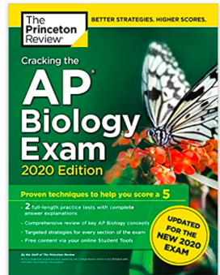

Graphing and Statistics Review
Graphing is an important procedure used by scientists to display the data that is collected during a controlled experiment. When a graph is put together incorrectly, it detracts the reader from understanding what you are trying to present. Most graphs on the AP exam are graded based on 5 major parts:
- Title—depicts what the graph is about. Reading the title gives the reader an understanding about the graph.
A good title is closer to a sentence than a phrase and is usually found at the top of the graph. It often
includes both variables. (Ex: The effect of rainfall on plant growth).
- X-axis scale and labels: The X axis should include your independent variable—the variable that can be
controlled by the experimenter.
- Y-axis scale and labels: The Y axis should include your dependent variable—the variable that is affected
directly by the independent variable (what you are measuring).
*Scale doesn’t always have to start at zero, but it must be consistent. If you start off making each box
worth 5cm, each subsequent box much also be 5cm. Always make sure your scale is labeled with units. Your scale should be appropriate so that as much of the graph paper is used as possible.
- Appropriate type of graph and legend (if applicable)—You should know the appropriate time to use a bar graph vs a line graph vs a scatter plot. They have different purposes. Also, make sure that your line graphs DO NOT connect to (0,0) unless this is an actual data point.

Experiment 1—Use the following data to answer the questions and create a multiple line graph.
Time after  Eating (hours) | Blood glucose of  Person A (mg/dL) | Blood glucose of  Person B (mg/dL)
0.5 | 170 | 180
1 | 155 | 195
1.5 | 140 | 230
2 | 135 | 245
2.5 | 140 | 235
3 | 135 | 225
4 | 130 | 200

  - What is the independent variable?

  - What is the dependent variable? How do you know?

  - Whenever possible, it is best to title graphs as “The
effect of IV on DV” where IV indicates the independent variable and DV indicates the dependent variable. Using this formula, what would you title your graph?

  - Why is a multiple lines type of graph best for this data? Explain based on the purpose of the graph.

  - Graph the data below. Be sure to include all of the required parts.

  - Why is a multiple lines type of graph best for this data? Explain based on the purpose of the graph.

  - Graph the data below. Be sure to include all of the required parts.

  - A common theme in Biology is homeostasis and feedback mechanisms. The human body uses many examples of negative feedback to maintain homeostasis, or a constant internal environment. For example, you use sugar as a source of energy. To maintain constant levels, you must continue to eat, but your body also uses different enzymes to store or release glucose into your blood to be brought to cells for use. People who are diabetic are either unable to create insulin or are unable to use insulin. This means that their blood glucose levels are not regulated by these enzymes. Which individual shows symptoms of diabetes?

  - Find the mean, median, and range for the data. Show work when necessary.

Person A Mean:

Median: Range:

You must show ALL WORK. Make sure graphs have Titles and are properly labeled WITH UNITS:
Graph the following sample data set showing the number of leaf disks that rise in a solution over time as photosynthesis occurs.
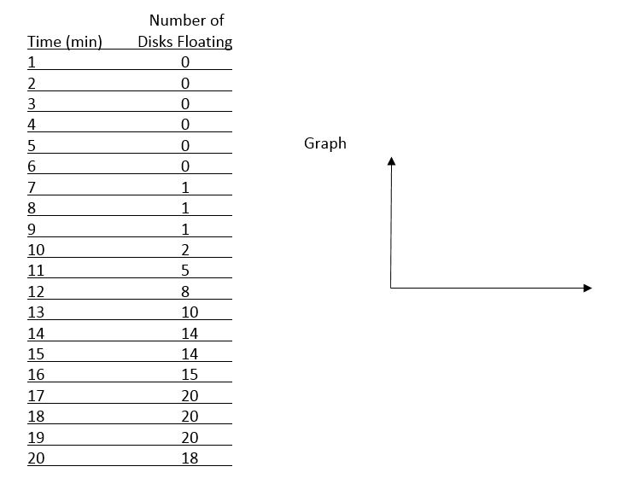

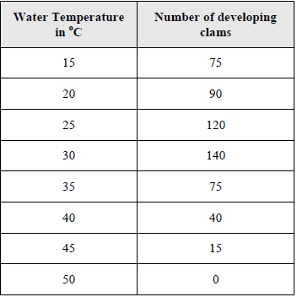
A clam farmer has been keeping records concerning the water temperature and the number of clams developing from fertilized eggs. The data is recorded in the chart: Make a line graph of the data on graph paper.
Connect these data points with a smooth line.

What is the dependent variable?

What is the independent variable?

According to the data, what is the optimum temperature for clam development? ______________

Review QUESTIONS:
Answers MUST be handwritten, or NO CREDIT GIVEN! Pay attention to what the prompt asks you to do (ex-describe). Prompt words have been underlined for many questions, below.

- Diagram 2 water molecules and indicate the Hydrogen bond(s) with labeled dashed lines.
- Describe how the pH scale works (in terms of H+ and OH-) Explain how buffers resist changes in pH (refer to carbonic acid/bicarbonate for an example)
- List at least 5 properties of water.
- Explain why water is a good solvent (include the terms polar and hydrophilic)
- Compare & contrast cohesion and adhesion. Give an example of each as it relates to a living organism (ex- root uptake of a tree)
- What was the Urey-Miller experiment and why what it so important?

Fill in the table

Macromolecule | Monomer | Polymer | Linkage bond
Carbohydrates

Proteins

Nucleic Acids

Lipids

Resources-
Here are a few resources for you to look over if you have time this summer. There is nothing due here. I just want to give you a chance to consider some of the material we will be covering.
1. Spend some time familiarizing yourself with the AP exam- https://apstudent.collegeboard.org/apcourse/ap-biology
2. AP exam tips- https://apstudent.collegeboard.org/apcourse/ap-biology/exam-tips
3. The http://www.bozemanscience.com/ap-biology/ has some great resources including information on many of the labs we will be doing.

4. This quizlet link below has a thorough list of all the vocabulary you will need to know-a great resource for review as well.
https://quizlet.com/22315269/ultimate-ap-biology-vocabulary-review-flash-cards/

